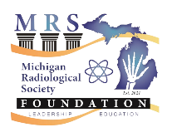
Michigan Radiological Society
Medical Student Section
Application for Scholarship to ACR 2023 Annual Meeting, DC

A $1,000 scholarship will be awarded by the Michigan Radiological Society Foundation for expenses (room and airfare) to attend the 2023 ACR Annual Meeting. The conference will be from May 6-10 in Washington DC. The candidates are asked to complete an application which will be anonymized. Each application will receive a numerical score (1-10) ranked by select members of the Medical Student Committee and the Diversity, Equity and Inclusion Committee. The application is due on 3/3/2023. The winner will be announced on 3/13/2023.

Why are you interested in attending the ACR national conference?

What interests do you have in the field of radiology?

What ideas do you have for MRS DEI and Student Section for this year?
Return completed application to Shannon Sage at shannon@michigan-rad.org

Scoring: to be completed by the committee:

Score 1: ________

Score 2: ________

Score 3: ________

Score 4: ________

Score 5: ________

Score 6: ________

Score 7: ________

Score 8: ________

Score 9: ________

Score 10: ________

Average Score: ________

Name:
Email:
Medical School:

